Day 10 Beginner Functions with Outputs

<https://stackoverflow.com/questions/8347048/how-to-convert-string-to-title-case-in-python>

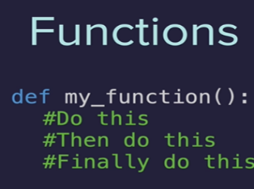

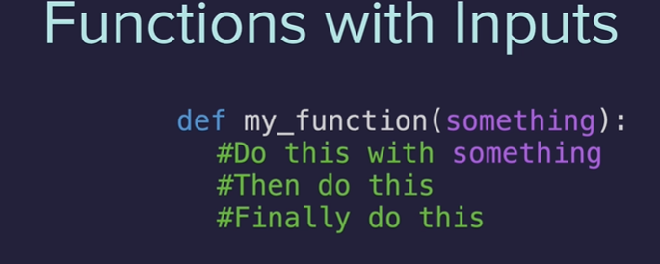

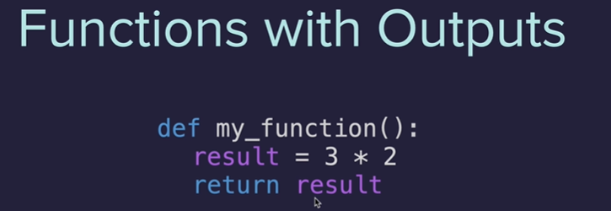



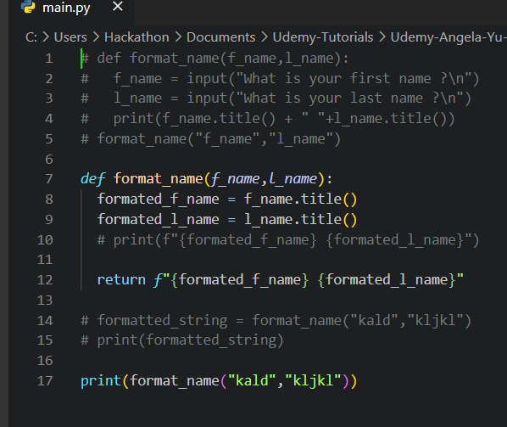

<https://www.udemy.com/course/100-days-of-code/learn/lecture/19658784#questions/13184740>

return ends the function

The print statement never gets executed

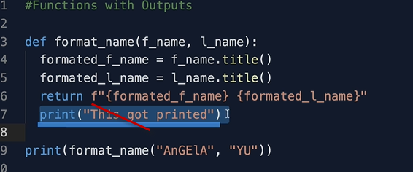

Terminate the function if the first and last name were not entered



Docstrings – document as you code

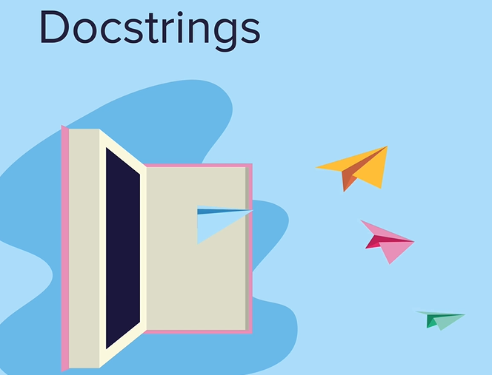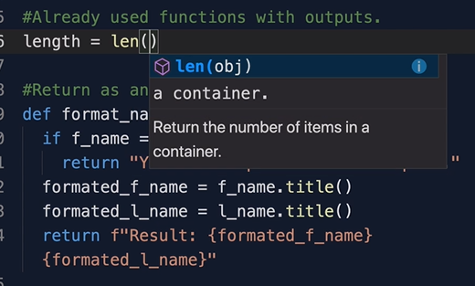

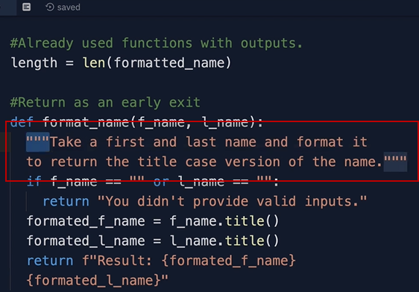 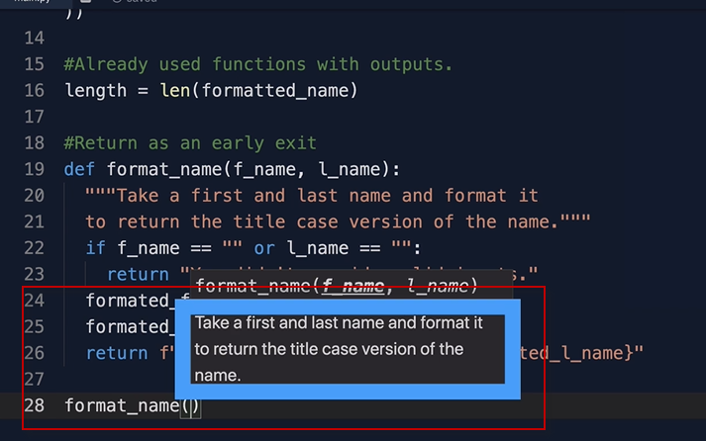

Build the calculator

<https://www.w3schools.com/python/gloss_python_function_recursion.asp#:~:text=Python%20also%20accepts%20function%20recursion,data%20to%20reach%20a%20result>.

